The University of York
SG 14: Spring Master Class
1-2 March, 2013
Bulk Glass, Plain Glazing, Archaeological Glass History, Technology and Conservation
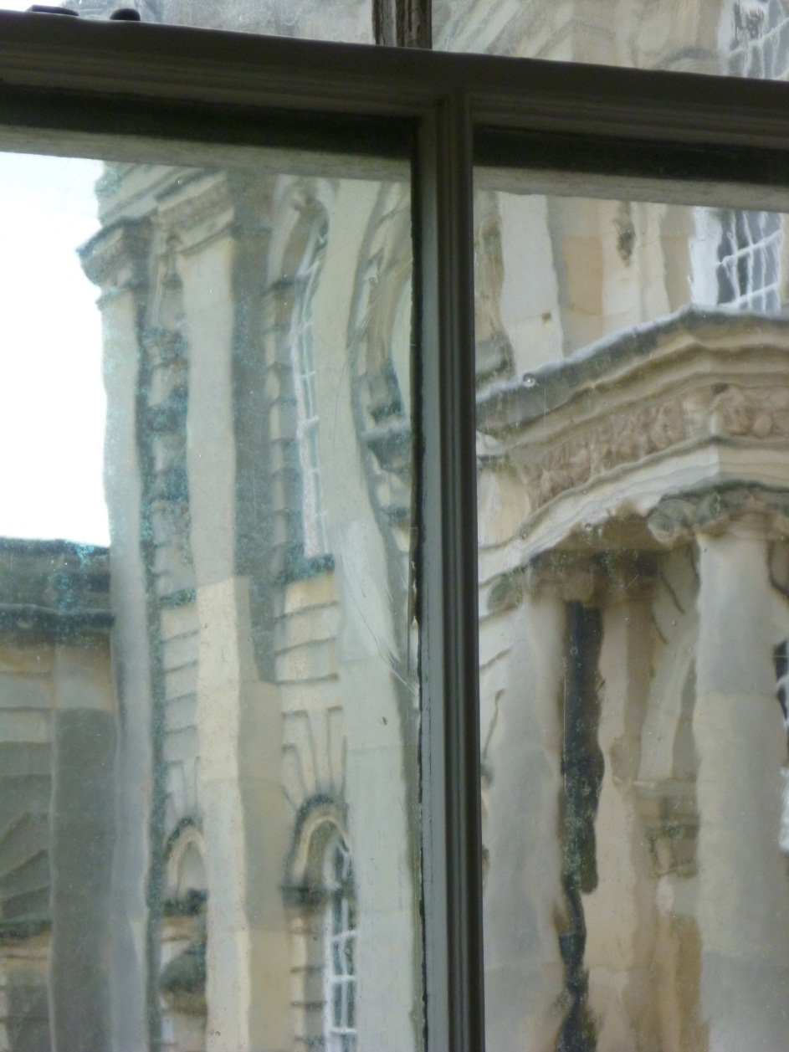
This event, to be hosted in the historic King’s Manor campus in the centre of York, will focus on glass – bulk glass, ‘plain glazing’, ‘white’ glass, and archaeological glass, its technology, history and conservation. An international panel of speakers will present recent research and new conservation applications. Tea, coffee and a sandwich lunch is included in the ticket price.
PROGRAMME
The event will commence with an evening lecture (5.00pm) and drinks reception on Friday, 1 March, with a full day of papers on Saturday, 2 March
Friday 1 March, 17.00 Professor Ian Freestone, University College, London ‘Latest research on medieval glass composition’ (title to be confirmed)
Saturday 2 March Coffee/registration: 9.30am Start: 10.00am
Dr Ivo Rauch, University of York ‘From Bathhouse to Bauhaus: Window Glass and Architecture’
Dr David Dungworth, English Heritage, ‘Chemical analysis of plain window glass: technology, dating and conservation’
Reiner Meindl, Glashuette Lamberts, ‘White glass production for the 21st Century’
Professor Hannelore Roemich, The Institute of Fine Arts, New York University, ‘Archaeological glass: surface degradation and conservation challenges’
Detach Here:-:-:-:-:-:-:-:-:-:-:-:-:-:-:-:-:-:-:-:-:-:-:-:-:-:-:-:-:-:-:-:-:-:-:-:-:-:-:-:-:-:-:-:-:-:-:-:-:-:-:-:-:-:-:-:-:-:-:-:-
SG 14: Spring Master Class, 1-2 March, 2013
Venue: The University of York, The King’s Manor, York YO1 7EP
I/We wish to take part in this event, and enclose a cheque for £65 per person made payable to The University of York.

Name(s) and Address:

Email/telephone: Date:

Please complete this form and return it, together with your remittance, to Brittany Scowcroft, The Centre for Medieval Studies, The University of York, The King’s Manor, York YO1 7EP by no later than 26 February 2013.
Cheques should be made payable to The University of York.
Participants from overseas may pay in cash on arrival.
Tel: 01904433910; email: brittany.scowcroft@york.ac.uk

